Mounika karampudi.
16158193.

LAB 3 Document

TASK1: To generate a sensor.txt file, we have to import and do the modifications to the code Hbase Client.java and sample.java. Connect to the Android phone and run the application.Then the following text file generates.

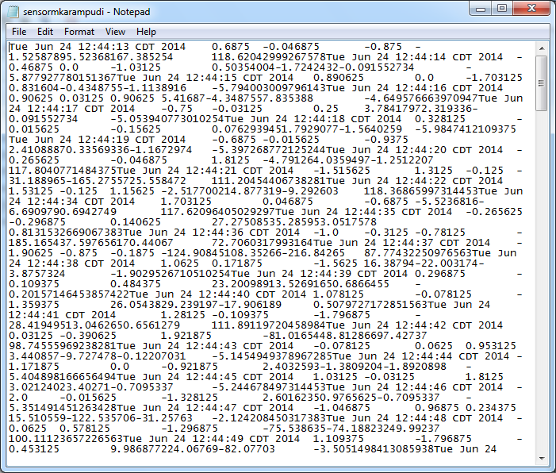
TASK2 File Transfer:

We have to transfer file from local machine to cloudera.Import Hbasefrontend.java file and make some changes as shown below.In Sample.java code add the method connectssh() as shown below and run the application by uncommenting connectssh() method.Then we can see the following output in 'Console' window.Upload is successful.
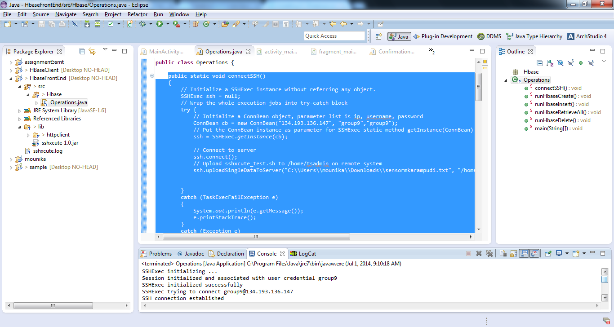

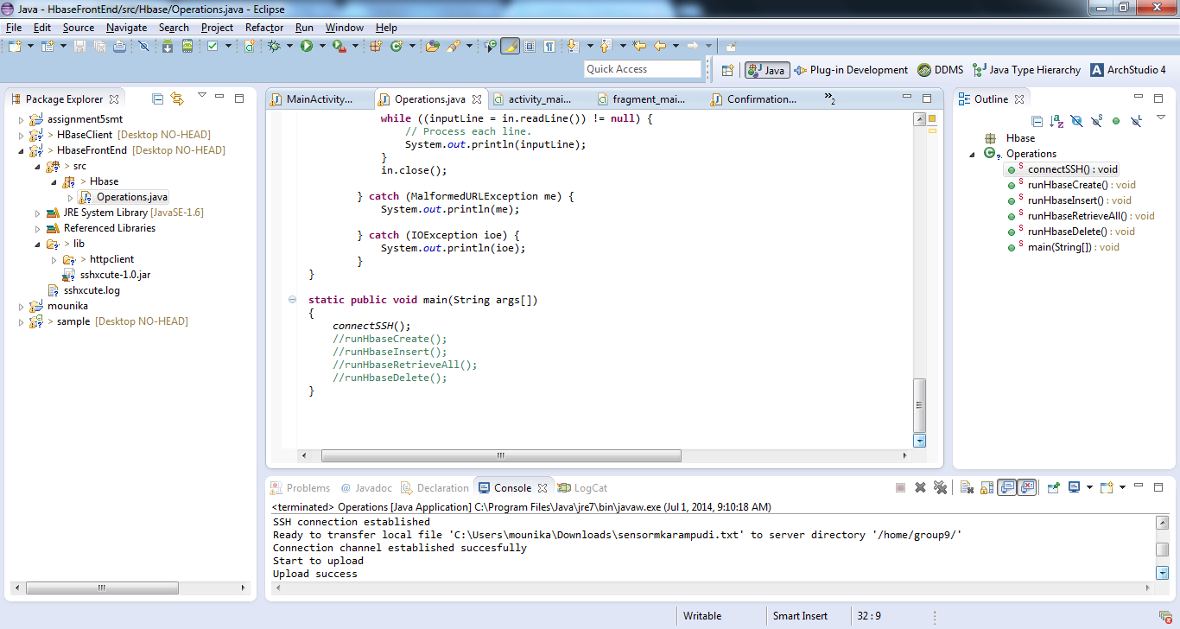

Similalrly by uncommenting the 'runHbaseInsert' we get the output in console as follows:
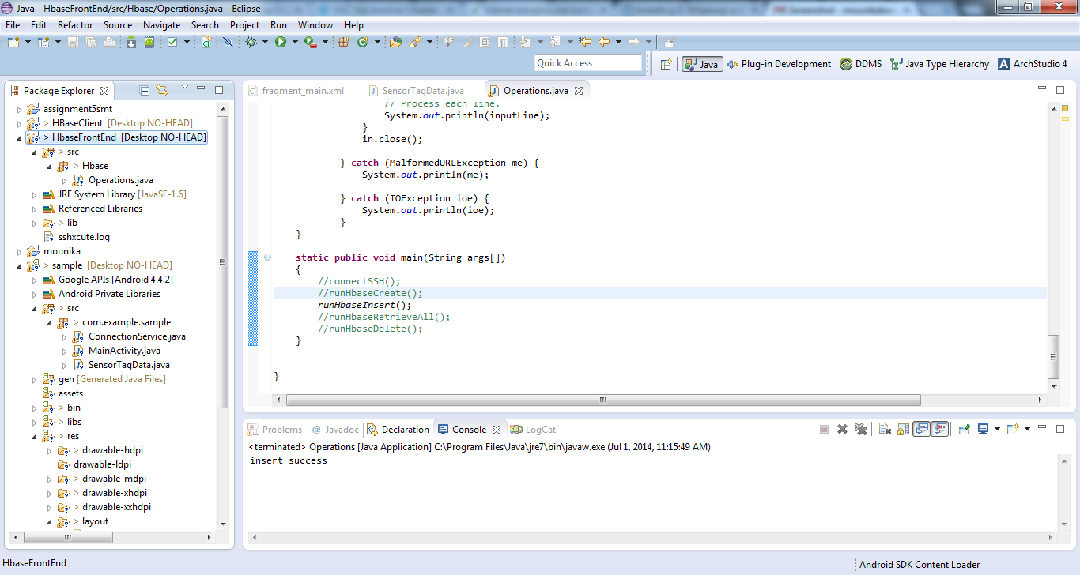

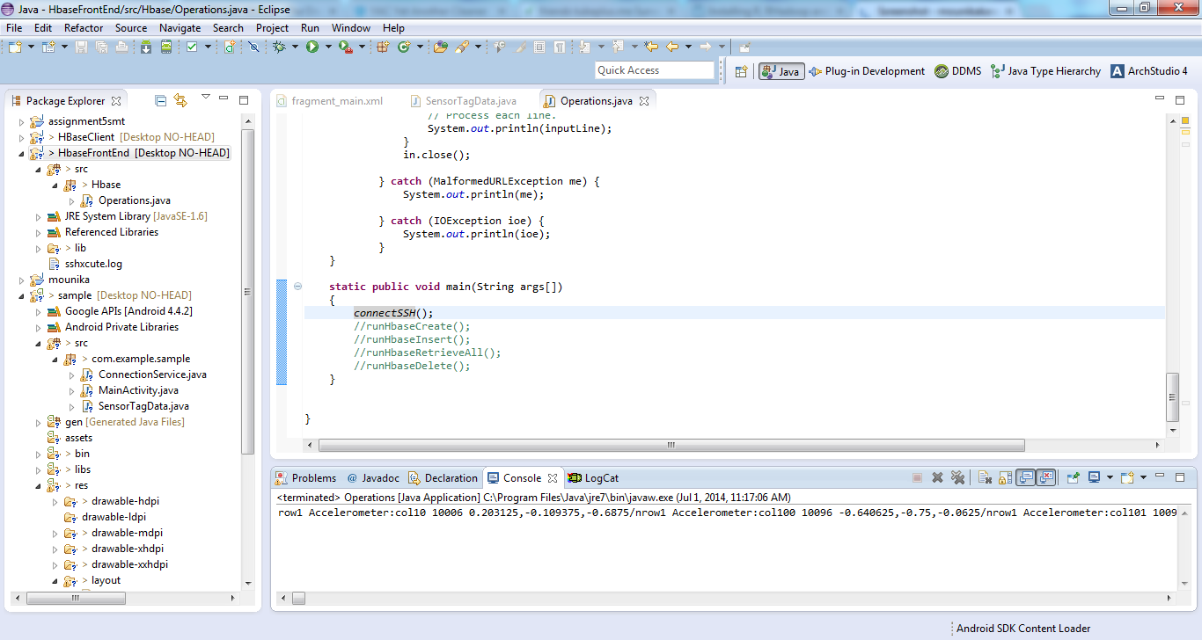

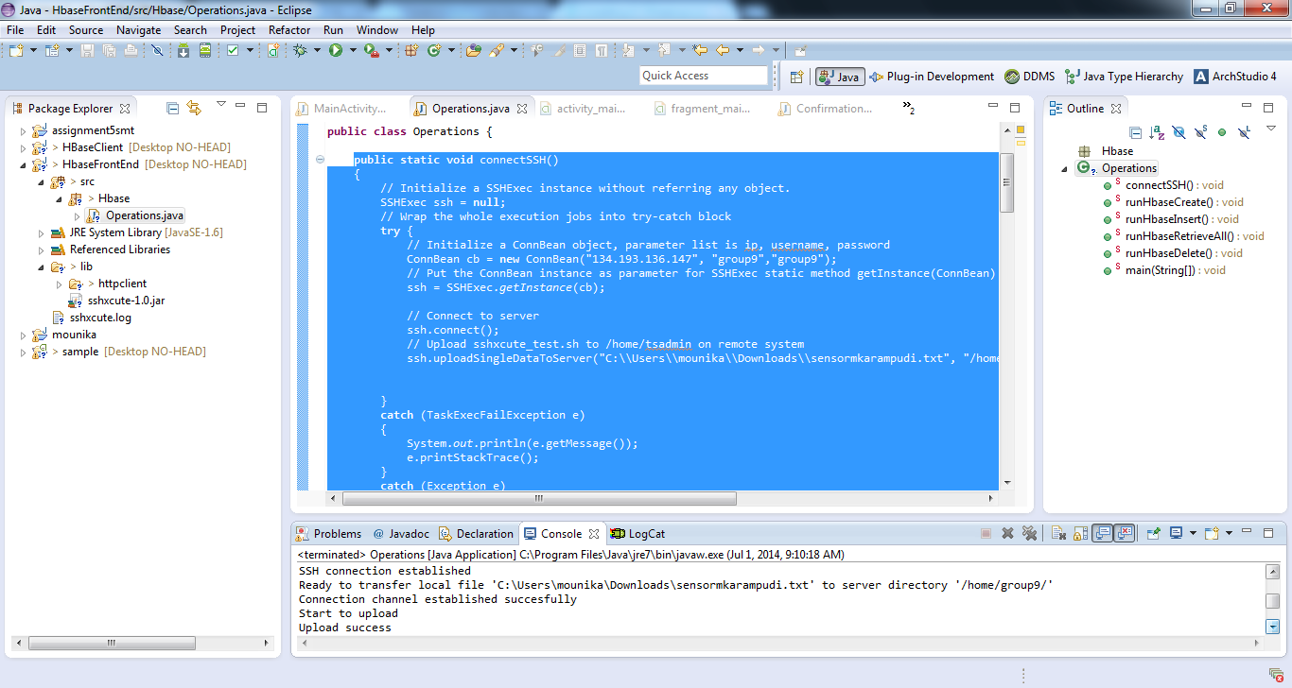

Now in Fragment_main.xml we have to add the code android.onclic=connectssh as shown below:

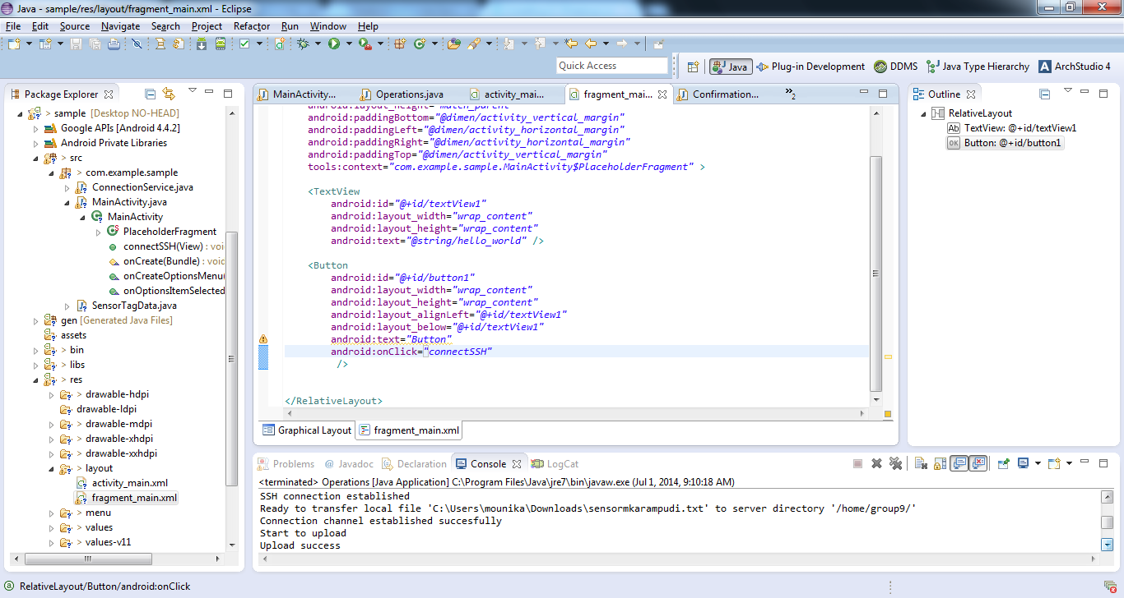

Then go to Graphical Layout and drag and drop the 'Button' to the right window as shown below:
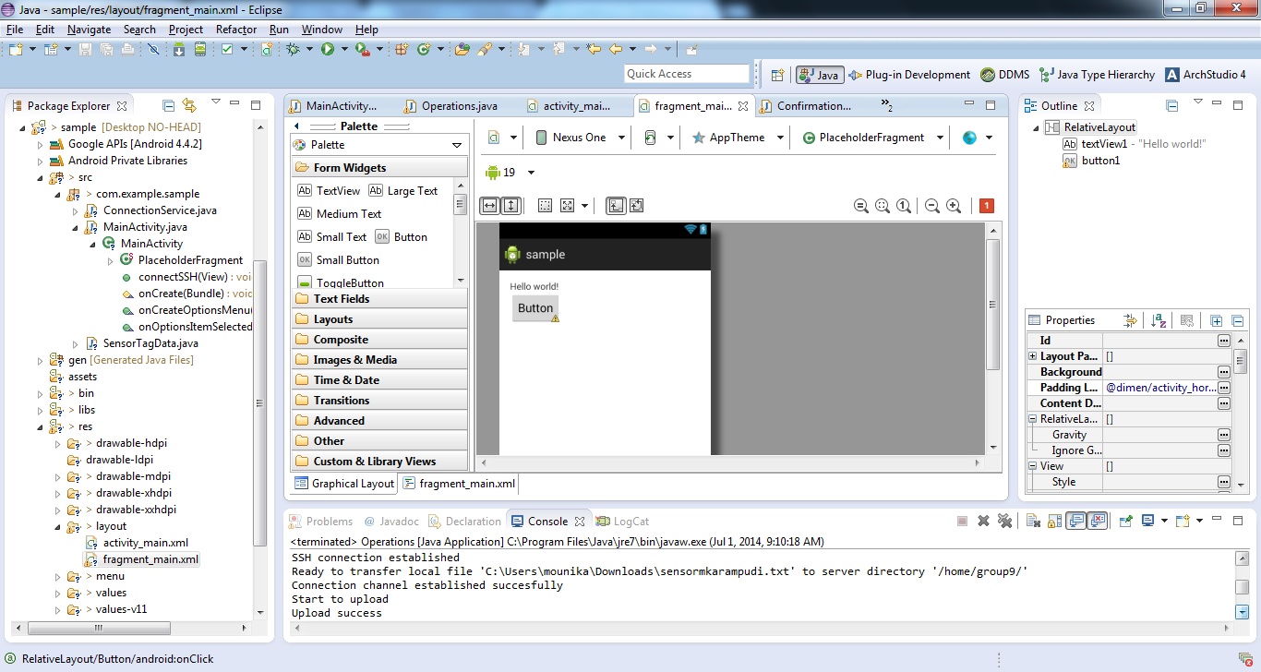
Now,if we want to check whether the sensor text file is uploaded in cloudera, open putty and type 'ls' command then the following list is displayed with the text file 'sensormakarampudi' as shown below:

